**Issue Passing Data**

SUMMARY:

We are having issues passing a specific combination of data through the Eris-Contracts javascript library. To illustrate this issue, we have a function that takes in four *strings*, one *bytes32* object and one *uint*. The function returns the exact values passed into it. The output in Eris-Contracts is null.

INPUT:

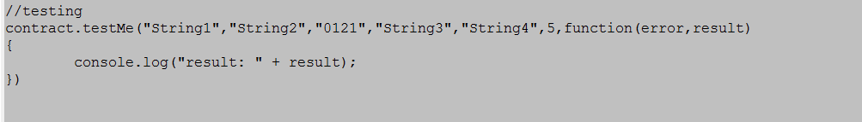

OUTPUT:



RECREATION:

The CONTRACT, EPM and JAVASCRIPT are included for recreation.

contract test

{

function testMe(string A1, string B1, bytes32 C1, string D1, string E1, uint F1) returns (string A, string B, bytes32 C, string D, string E, uint F)

{

A1 = A;

B1 = B;

C1 = C;

D1 = D;

E1 = E;

F1 = F;

}

}

jobs:

- name: one

job:

deploy:

contract: test.sol

wait: true

JAVASCRIPT:

'use strict'

var contracts = require('eris-contracts')

var fs = require('fs')

var http = require('http')

//Set up addresses for deployed contracts

var address = require('./epm.json').one

// Set up abis for deployed contracts

var abi = JSON.parse(fs.readFileSync('./abi/' + address, 'utf8'))

var accounts = require('./accounts.json')

var chainUrl

var manager

var contract

var server

var hostname = 'localhost';

var port = 8002;

//URL to the rpc endpoint of the eris-db server

chainUrl = 'http://localhost:1337/rpc'

//Instantiate the contract object manager using the chain URL

//and the account data.

var manager_full = contracts.newContractManagerDev(chainUrl, accounts.tuesday4_full_000)

// Instantiate the contract object using the ABI and the address.

var contract = manager_full.newContractFactory(abi).at(address)

//testing

contract.testMe("String1","String2","0121","String3","String4",5,function(error,result)

{

console.log("result: " + result);

})